This is from the old production environment. You can see the printer was redirected there as well.

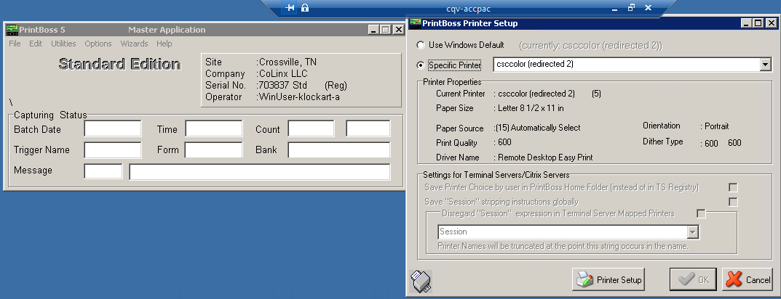

This is from the new environment

